
WEXNER CENTER FOR THE ARTS “ZOOMS” INTO 5TH ANNUAL FAMILY FILM FESTIVAL
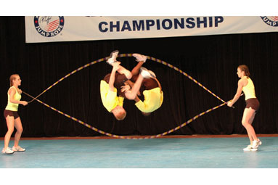4-DAY FESTIVAL INCLUDES LOCAL PREMIERES, JUMPROPE EXTRAVAGANZA, CEREAL & PAJAMA PARTY, LIVE MUSIC, ICE CREAM SOCIAL, MORE
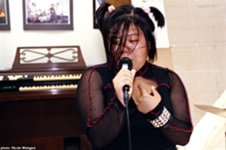
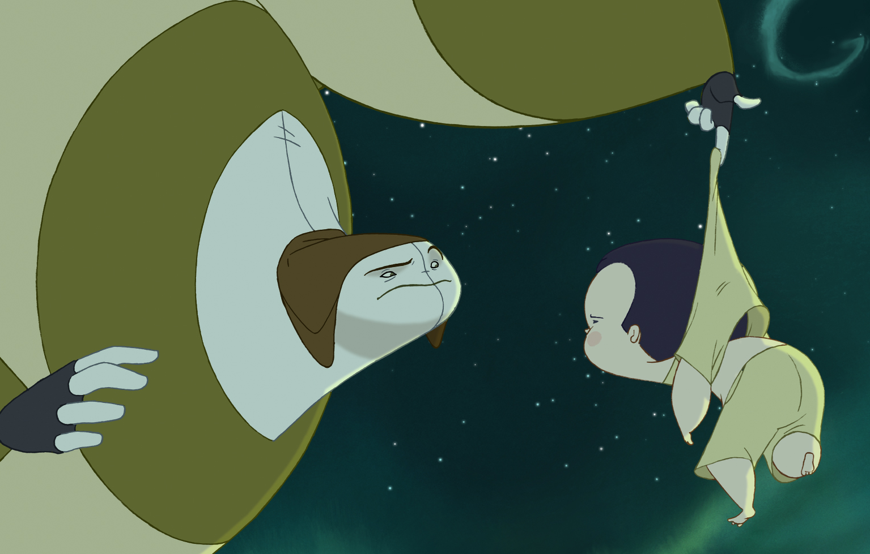The Wexner Center’s Zoom: Family Film Festival (formerly Columbus International Children’s Film Festival), featuring films from around the globe, will take place December 4–7, 2008. This year’s lineup includes the sensational documentary JUMP! in its local premiere, followed by a demonstration of competitive jump roping, and the local premiere of Girls Rock! about girl rock-band camps (also with a short live performance by a local girl band). Other films hail from Iran, Brazil, Spain, and Germany. In between films on Saturday and Sunday, families can take part in art projects or join a tour of the exhibition Andy Warhol: Other Voices, Other Rooms. Other highlights include a Saturday morning Cereal and Pajama Party followed by a screening of classic Disney cartoons, and an Ice Cream Social on Saturday.
Above: Jump! Photo courtesy of Amy Simpson/Nutshell Productions, LLC.
Left: Girls Rock! Photo by Nicole Weingart, image courtesy of Shadow Distribution.
Below: Nocturna (Spain) Image courtesy of Filmax International

.

Notes Dionne Custer, co-organizer of the event and the Wexner Center’s educator for school programs, “We are pleased to announce the lineup of this year’s ever–growing festival, including a live performance of competitive jump ropers and a visit by a local all–female rock band. In addition, we hope that the international films will broaden children’s horizons and trigger discussion with their families and friends.”
Chris Stults, co-organizer of the festival and an assistant curator in Wexner Center’s film department, says “This festival represents some of the best filmmaking in contemporary and classical cinema from around the globe. With a special presentation of The Golem—a silent version of the ancient Hebrew tale performed with live klezmer music—and the caliber of this year’s films (including several regional premieres), we feel we’re offering an unforgettable film opportunity for local families.”
The schedule follows.

ZOOM: FAMILY FILM FESTIVAL
Thursday, December 4 | 7 pm
Columbus theatrical premiere
Girls Rock! (Anne Johnson & Shane King, 2007, USA)
Performance and discussion with local girl band the Mary Anns after the movie.
Providing a delightful and raucous dose of girl power, the documentary Girls Rock! (90 mins.) tracks the musical (and personal) education of several campers at the Rock 'n' Roll Camp for Girls in Portland, Oregon. Girls ages 8 to 18 come to the camp from all over the country to learn from counselors like Carrie Brownstein from Sleater-Kinney and Beth Ditto from The Gossip. Presented in partnership with Girlz Rhythm and Rock Camp. Recommended for ages 8 and up.

Friday, December 5 | 7 pm
Columbus theatrical premiere
JUMP! (Helen Hood Scheer, 2007)
A lively and inspiring documentary, Jump! (85 mins.) follows five teams from around the United States (including two from Ohio) who push their physical and psychological limits in pursuit of winning the World Rope Skipping Championship. The Friday night screening is introduced by Tori Boggs, the world record holder for three-minute speed jumping and one of the most memorable athletes profiled in the film. Boggs is again on hand for Sunday’s encore screening (see Sunday listing for details on this screening and other related events).

Saturday, December 6
9:15–10 am:
Cereal and Pajama Party
Roll out of bed and make your way to the Wexner Center for some free cereal with your Saturday cartoons. Kick start your day at the festival by pouring yourself a bowl at the cereal bar provided by Whole Foods Market. Kids in pajamas receive a special surprise. The party is a great way to get ready for our 10 am screening of favorite Disney cartoons.

10 am:
Saturday Morning Cartoons: Disney Classics (various directors, USA)
Join us for an enchanting program of cartoons specially chosen from the countless treasures in the Disney vaults, featuring some of the greatest moments of the most popular cartoon characters ever brought to life: Mickey Mouse, Donald Duck, Pluto, and more. Among the titles we’ll show are the classics Clock Cleaners (1937) and Lonesome Ghosts (1937). Recommended for ages 4 and up.

11:15 am:
Children of Heaven (Majid Majidi, 1997, Iran)
The first Iranian film to earn an Oscar nomination for Best Foreign Language Film, Children of Heaven (89 mins.) is a crowd-pleasing classic of 1990s’ children’s and world cinema. When young Ali loses his little sister’s shoes, the two decide to share Ali’s shoes and hide the loss from their parents. The film builds to a sublime footrace that will have audience members of all ages on the edge of their seats. Rated PG for some language. Recommended for ages 8 and up.

12:50 pm:
Family Tours and Art Projects
Take a free 30-minute family-friendly interactive tour of Andy Warhol: Other Voices, Other Rooms, the exhibition on view in the galleries. Tours meet at the gallery entrance. You can also join in free self-directed art activities throughout the day on Saturday and Sunday.

1:30 pm:
Meet Me in St. Louis (Vincente Minnelli, USA, 1944)
One of the finest musicals ever made, Meet Me in St. Louis (113 mins.) has been a beloved and heartwarming piece of Americana for generations. The film follows a family of four daughters through the seasons, closing in winter with Judy Garland’s unforgettable performance of “Have Yourself a Merry Little Christmas.” It’s a perfect preface for the holiday season. Recommended for ages 7 and up.

2:30–4:30 pm:
Ice Cream Social
Between screenings on Saturday, please join us for a free ice cream social featuring an assortment of flavors from Jeni’s Splendid Ice Creams, a Columbus favorite. The social comes right after our screening of the classic musical Meet Me in St. Louis, in which the characters (like the rest of the country) discover the ice cream cone at the 1904 St. Louis World’s Fair.

3:45 pm:
Midwest premiere
Nocturna (Adrià García & Victor Maldonado, 2007, Spain)
Ever wonder what happens at night while you’re asleep? The lusciously animated film Nocturna (80 mins.) shows what happens when one boy, Tim, stays up and ventures out one night into a magical world while everyone else is in bed. Since Nocturna doesn’t have American distribution at the moment, don’t miss what might be your only chance to see this visually rich fairytale. Recommended for ages 6 and up.
Wexner Center members can attend the Nocturna screening free as part of Member Appreciation Days. Show your membership card at the Patron Services Desk to get your free ticket.

7:30 pm:
The Golem (Paul Wegener & Carl Boese, 1920, Germany)
Silent film with live klezmer music by clarinetist David Krakauer
Tickets are $8 for the general public, $6 for members, students, and senior citizens and are not part of package discounts.
Widely recognized as the source of the Frankenstein myth, in the ancient Hebrew tale of The Golem (91 mins., silent version) a rabbi creates a giant warrior sculpted of clay and intended to protect his people. Accompanying the film for this one-time screening are the internationally acclaimed klezmer clarinet virtuoso David Krakauer and the innovative Carpe Diem String Quartet, performing an original written by Israeli composer Betty Olivero. Recommended for ages 12 and up.

Copresented by Ohio State’s Melton Center for Jewish Studies and the Lenore Schottenstein Jewish Arts Fund of the Columbus Jewish Foundation. Mr. Krakauer is exclusively represented by Bernstein Artists, Inc. (www.bernsarts.com).

Sunday, December 7
12:15, 2 & 3 pm:
Family Tours and Art Projects
Take a free 30-minute family-friendly interactive tour of Andy Warhol: Other Voices, Other Rooms, the exhibition on view in the galleries. Tours meet at the gallery entrance. You can also join in free self-directed art activities throughout the day on Saturday and Sunday. (Sunday activities are part of Faces and Places, a family-friendly afternoon of activities in conjunction with our Warhol exhibition, including screen tests, photo booths, and more). Tours begin at 2 pm and 3 pm.

1 pm:
JUMP! (encore screening; see Friday listing for details)
Tori Boggs, the world record holder for three-minute speed jumping, is again on hand for this encore screening of JUMP! (see Friday’s listing for details on the film). Joining her for a post-screening discussion and Q&A are two other world champion jumpers from the film, Nick Woodard and Jeff Maus—all of whom will then head over to Mershon Auditorium for a performance (see next entry).

3 pm:
Jumps and Stunts
This dynamic jump rope performance and interactive demonstration will feature Tori Boggs of the River Valley Skippers from West Virginia, Nick Woodard and Jeff Maus of Raz Ma Tazz in Texas, and Lee of Summerwind Skippers in Idaho showing their moves in a jump roping performance and interactive demonstration that is sure to leave the audience inspired, invigorated, and motivated.

3:30 pm:
Ohio premiere
Tainá 2: A New Amazon Adventure (Mauro Lima, 2004) – Free screening
This sequel to Tainá: An Amazon Adventure (76 mins.), one of the most popular films from our 2006 festival, provides another great opportunity for a short tropical vacation before the start of a Midwestern winter. Now 13, Tainá is the elder to a tribe of youngsters who find themselves in an adventure to foil a team of illegal poachers. Even if you didn’t see the first film, you’ll delight in this story of friendship, courage, and the importance of environmental conservation. This film was voted Best Live-Action Film/Children’s Jury Prize at the Chicago International Children’s Film Festival. Subtitles will be read aloud. Recommended for ages 6 and up.

CAFE AND STORE DURING THE FESTIVAL
Visitors will find child-friendly items on the menu in our café, Cam’s on Campus. And the Wexner Center Store, as usual, has toys, gifts, and books for all ages.

TICKETS and VISITOR INFORMATION: Tickets for each individual film are $3 for the general public and $2 for members, available at the door or in advance at 614 292-3535, on sale now. Packages of any six tickets are $15 for the general public and $10 for members (prices apply to all films except The Golem special event, which is also not included in the ticket package). The Wexner Center is located at 1871 N. High St. at 15th Ave. at The Ohio State University (wexarts.org); the public can call 614 292-3535 or stop into the Wexner Center for advance tickets. Note: The public can call Dionne Custer, educator for school programs, at 614 292-7008 to discuss any film before viewing it with children. PARKING INFORMATION: Convenient parking is available in Ohio State’s Union Garage, with entrances from North High Street and College Road. The Wexner Center is also on several COTA bus lines (#2, #18, #31, and #84).

EVENT AND SEASON SUPPORT
Zoom: Family Film Festival is presented with support from Bob Evans Farms and Jeni's Splendid Ice Creams.

Promotional support is provided by Suburban News Publications.

Significant contributions for the Wexner Center’s 2008–09 film/video season are made by the Rohauer Collection Foundation.

All film/video programs and events also receive support from the Corporate Annual Fund of the Wexner Center Foundation and Wexner Center members, as well as from the Greater Columbus Arts Council, The Columbus Foundation, Nationwide Foundation, and the Ohio Arts Council.

Media contacts: Tim Fulton, tfulton@wexarts.org or 614 688-3261; or Karen Simonian, ksimonian@wexarts.org or 614 292-9923.

###30###

